|  |
| --- |
| Goldsmiths university |
| Creating character class via dialogue events. |
| Using in game events to create scenarios in which the player builds their own class. |
|  |
| **Michael Craddock/ Mcrad001** |
| **9/8/2016** |

|  |
| --- |
| This document will be going over the possibilities of creating a system that allows the player to build up their character to class via actions they do in the game itself, how it would work and in what ways and scenarios could work. |

Contents

Abstract 2

Introduction 2

Theory 4

Multiple choices 5

Meaningful choices 8

Storytelling 12

Conclusion 17

Implementation 18

Step 1 18

Step 2 20

Step 3 20

Step 4 20

Step 5 21

Test results 21

Initial response 22

Initial testing 22

Conclusion of testing 23

Overall thoughts 24

Conclusion 24

Bibliography 25

Figure 1: Dragon Age (Bioware, 2009) 3

Figure 2: Mass effect (Bioware, 2007) example of multiple choices 6

Figure 3: The walking dead episode 1 (TellTale Games, 2012) 8

Figure 4: Life is strange (Dontnod Entertainment, 2015) example of choices 9

Figure 5: String of pearls example. 13

Figure 6: Branching string of pearls example. 14

Figure 7: Example of the Hero's Journey (Image found at http://www.thewritersjourney.com/hero's_journey.htm) 17

Figure 8: Code example 1 18

Figure 9: Unity script inspector for the dialogue. 19

Figure 10: Code example 2 19

Figure 11: Code example 3 20

# Abstract

Just want to quickly thank everyone who helped support this project and helped build it up especially my mother for being super supportive and helpful throughout this all. If more information is desired on this project you can find all the details on my GitHub at <https://github.com/MichaelCraddock/Dissertation-project>. Thank you for your time and enjoy.

# Introduction

In this document we’ll be discussing the use of a system that allows the player to create their class around actions they do in the world they are in. This system in theory should allow for the player to become more involved with their character class and have them feel like their class has an impact on more than just how they play the game via skills, but also should impact what happens in their game and how the world possibly reacts to them as a player. Throughout this we’ll be going over the core aspects of the system such as class stereotypes and storytelling and how these need to complement each other, multiple choices as to allow the player choices in multiple scenarios and how the player should be able to get some feedback from these events and how to make these choices meaningful and eventful, and not a harmful experience for the player.

Before we delve into the parts behind the system and the theory behind it, firstly we’ll look at what we’re trying to accomplish by creating a system like this. In most single player Role playing games (RPGS) the player is often given the choice at the start of the game to choose between various different classes. These then set the player on a predetermined path on how they’ll play the game but not always do they have much meaning outside of that. For example say you’re playing a medieval fantasy RPG and you choose to play as a rogue but you find out there is very little interaction with your class outside of the way you play it. This system is an attempt of trying to create a more interactive feel with players and their classes. It allows the player to build a class around not only the way they want to play the game but the way they wish to act in the game. This kind of dialogue system effects how the world plays out can be seen in some games out already such as the Mass effect(Bioware, 2007) trilogy or the Dragon Age(Bioware, 2009) series where the player is often given multiple choices in dialogue that will greatly affect the story and what happens.

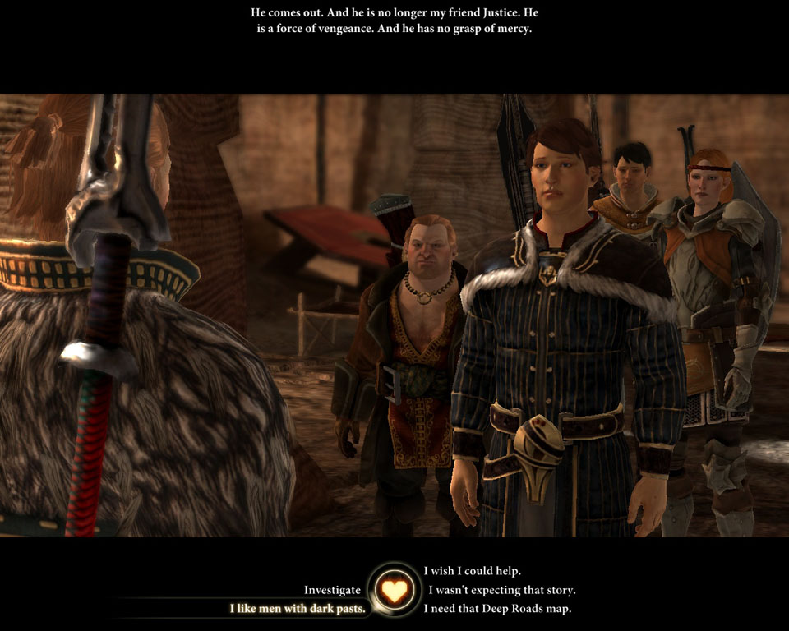

Figure : Dragon Age (Bioware, 2009)

However this still isn’t exactly what this system hopes to do as in mass effect whilst the conversations can affect the world around you, the class fantasy is not there. The class is still just a title that you have that grants you special abilities and nothing more, there is no special dialogue options if you choose the Vanguard class and this takes away from class fantasy. The system that is being attempted in this project is to try and address the issue of class fantasy in RPGS as in most games it is lacking. Another example of a game that does have a similar system to what’ll be discussed here is Elder Scrolls: Skyrim (Bethesda, 2011) in which the player doesn’t actually choose a class at the start. Instead the player can build up certain attributes of different skills without the need of a certain class by continuously doing certain actions or abilities. This system is similar to the one created in this project because the player does not start off with a class, however in this case the player still doesn’t get the class fantasy that is desired. The player in this scenario can do everything as long as they sink the time into it, so for example they can max out every kind of skill and be a master of everything and do every quest regardless which whilst is certainly nice still takes a bit away from class fantasy as you’re taking away the uniqueness from classes at this point by letting a player do every type of quest. The system we’re trying to achieve is trying to get the balance between allowing the player to build up their own class and also making sure that class has a unique feel to it and allowing it to have unique interactions that you wouldn’t be able to do otherwise.

So now that we’ve gone over the problem we’re trying to solve and look at we’ll go into what we’ll be covering in this document. We’ll start off by covering the theory of the system and the mechanical and design thoughts that have gone into this system such as working on multiple choice conversations and how they can help create an interesting system, making sure that the player gets good feedback from the choices they make so they’re not just left unknowing of that choice they’ve made, how storytelling and writing impacts this system, and how this all can be put together and how it’ll all work as a singular system. The next stage we’ll cover is the implementation of how this project was done, covering the code and the steps that were taken in the creation of the project. We’ll also go over any changes that were made from the initial design and code to how it ended up and discussing on why they were changed and what impact these changes had on the project as a whole. Next we’ll be discussing the results from testers that helped to test during different stages of the project, what their thoughts on the theory and system prior to playing the game and then their thoughts on after testing it and comparing the results to see if there were any interesting correlations that could be made. Then finally we’ll go into the conclusion to wrap up the project as a whole and discuss what went right, what went wrong, what was learnt from the project and if anything could be changed.

# Theory

In this section we’ll be going over the theory of this system and discussing it in a bit more detail than earlier. How we’ll be doing this is by breaking down some of the major parts of this theory and discussing what about them works and what they add to the system as a whole, any pros and cons with each area and showing off some examples from other titles that implement certain parts of these mechanics. The sections we’ll be discussing here will be the use of multiple choices in a narrative setting and how they can effect players enjoyment and how they affect the overall way players go about interacting with non-playable characters(NPCS) and events around the world and how they can be used to help create choices to build up class fantasy. We’ll then talk about the meaningful choices and player feedback that needs to happen during these conversations and talking about how best to feed the player information on the choices they’ve made in a way that is enjoyable and informative. Then finally we’ll talk about how storytelling and the influences it has on the choices the player makes and the feedback that is given to the player using storytelling as a whole. At the end we’ll discuss how all these different parts combine together to create the system we’re using and how each point helps another point.

## Multiple choices

So let’s start off with one of the major parts of the system used, multiple choices. Multiple choices in this kind of system is almost needed as it provides the player with the ability of choice and gives us the power to give that choice some meaning, in this case will empower the players class depending on the choice they made. So let’s take a step back and look at the use of multiple choices as a whole in video gaming in general. The use of multiple choices allows the player to gain more of a unique experience that they feel they’re crafting themselves, it allows them to build up their own personal character and build a bond with the character they’re playing. Multiple choice systems are nothing new in video games and have been used in numerous types of genres for years. Whilst you do end up seeing multiple choices systems be used predominantly in RPGS it does have uses in all kinds of genres as it allows the designer to create scenarios based on the players choice rather than just shoehorning them down a linear path and forcing them to play a set character. As said earlier it allows the player to feel like their building up a characters personality by making certain conversation choices or moral choices via multiple choices. Most of the time when multiple choice systems are used it’s to create a morality system, allowing the player to choose between certain actions normally one being the perceived good action, one being the bad action and possible another one which is neutral. Normally in these games these choices either affect the world and how people interact with you or change how you look and how your character acts. Some good examples of these kinds of games include again the Mass Effect trilogy in which the player has numerous multiple choices during certain missions that give the player the choice of either a Paragon option for the good side option or a Renegade option for the bad side.

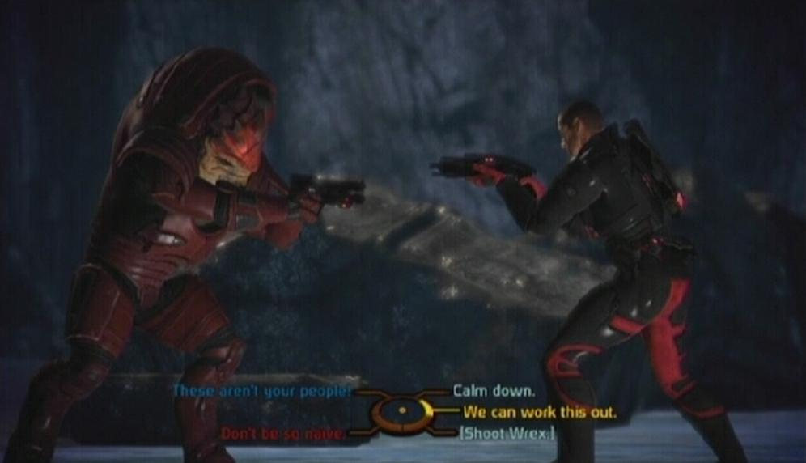

Figure : Mass effect (Bioware, 2007) example of multiple choices

As you can see in Figure 2 the player in certain scenarios are given multiple choices, each one of these choices can lead to a different results, but as you can see there are two options that are highlighted differently, one which is blue and the other which is red. These indicate the two prime moral options in the Mass effect universe. If you choose one it’ll give you a boost to that specific alignment. If you do keep choosing certain alignment choices you’ll get certain aesthetical changes and the entire world will react based on how you act. This system is one of the systems that really inspired this idea as it really does allow the player to build up their own main character and have them fight with hope and sympathy, or all out aggression and force. The main problem with this system is that in the end it is a bit shallow as it really only allows the option between black and white. Imagine a system like this but expanded to classes allowing the player choices that’ll either boost your class one way or it could boost it another way, an example of this could be for the change for a mage to become something like an arcane warrior where the player could be given multiple choices that give the player who has built up a mage class from actions already an option to evolve even further into a melee mage by either triggering certain events or talking to certain people. It could allow players so much interaction with their class and how they could build it up, change it and evolve it.

When looking at multiple choices there are some rules that really need to be addressed. Dan Fabulich wrote on his blog about five rules for writing interesting choices in multiple choice games (Choiceofgames.com, 2010) that really do seem to go over some very key points when deciding to use multiple choices in games. We won’t go over every rule he lays out, instead we’ll talk about some of the most important ones and give our take on them. The rules we’ll be looking at from his blog are “*Every option should have real consequence, the player needs some basis to make a decision, No options should be better than the other*” (Fabulich, 2010). When it comes to the first part saying every option should have some consequence, this is probably the most important rule, otherwise the player will feel no real consequence of their action and will not really understand why they choose that choice or what it’s done for them as a player. This needs to be addressed as if the choices the player makes have little to no consequence to them then there is little point to the choice even being there. The idea for the system would be that the player should really feel the consequence of choosing certain class fantasy to follow and really get an idea that because they’ve chosen to go down this specific route other routes will be closed off to them as they work to obtain more in the class they’ve followed. The second part about the player needing a basis to make the choice is another very good and interesting rule to follow and directly links into the meaningful choices section. “*Even if you’re guaranteed that every option has consequences, if players have no idea what the consequences of their decisions will be, it becomes impossible to make a meaningful choice.”* (Fabulich, 2010) This quote by Fabulich really shows how important it is to have a basis on why to choose something as he states, a choice might have some really interesting consequences to it, but if the player has no idea what those consequences are then there still going in fairly blind to this scenario. There must be some feedback to let them know what is going to happen, we’ll discuss this rule more in the meaning full choices section. And finally moving onto the last rule he goes over, that each option should not be better than the other, this is a very interesting topic as if the player is given the choice between one thing that’ll benefit them greatly and another thing that’ll only help them slightly and they know this ahead of time then they’ll always take the option that’ll benefit them the most, making the multiple choice option meaningless. Rather than give each option a value in this regard, for this system using class related choices, each option won’t essentially lead to a this is better than that choice, but rather this option will lead you down this path to upgrade your class in this way whilst the other options will either allow you down another different class route or allows you to ignore both routes and continue building up what you currently are. The aim would be that no option would hold a value in a sense and won’t hopefully be held down by option A is just a better choice than option B.

Looking at how multiple choices have been used in games to this day we can see that they’re used to primarily develop story and allow the player to almost build their own character and story line. Most titles end up using this to build a morality system giving the choice of good and evil, where as some other story driven games such as The Walking Dead (Telltale, 2012) or Life is strange (Square Enix, 2015) in where there is no morality system but instead the choices you make directly impact the story and change who lives and who dies, and possible consequences that could happen later down the line due to a choice made earlier.

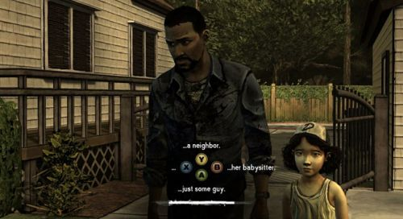

Figure : The walking dead episode 1 (TellTale Games, 2012)

This kind of system is more used for very heavy narrative driven games, which rely on player made choices and forces the player to make some very tough choices in a short period of time. The idea with the system that is being created in this project is to try and meld these two types of multiple choices and try and merge them to create a more engaging class fantasy. To be able to allow the player to get attached to their class, build up meaningful choices that allows them to evolve and build their class around the way they not only want to play the game but how they wish their character to be in the game.

## Meaningful choices

Moving on we’ll now talk about something we briefly touched on in the multiple choice section, the basis on choosing a certain choice. This is very important when trying to create a system like this as the player needs reason to choose something and they need to know what the possible outcome might be from choosing a certain action, even if it’s only a small hint. This is a fairly tricky problem to solve as you don’t want to go into too much detail as to why the player should make certain choices as otherwise they might feel like their being shoehorned down a certain path, but at the same time you shouldn’t give them almost an empty choice of three options that really don’t have any explanation of the consequences as otherwise they’re not really making any meaningful choice. An example of this kind of unknown consequence can be found in a choose your own adventure book called Journey under the sea (Montgomery, 1979) in which the player is given a choice to either explore a ledge or to cut loose and explore a canyon. If we were to put this into a gaming scenario how would the player really be able to make a meaningful choice in this scenario? Both options are exploration based and neither really gives enough reason to choose one over the other, it becomes a 50/50 choice in the end because there’s little known about what could possibly be at the ledge and reasons why to choose it over going to the canyon. There are obviously differences on how this sort of feedback should be handled when it comes to type of genre, as in games where the choices aren’t meant to be the overall impacting feature you can get away with fairly open ended choices as the player then won’t feel cheated when selecting certain choices as the choices in the end don’t impact them in such a way, however in games which rely on story and allowing the player to have choice and have it be meaningful really need to think of how to relay feedback to the player. Games such as The Walking Dead or Life is Strange as mentioned earlier rely heavily on multiple choices and having each choice influence something that’ll happen later on in the game in a major way, and the player must be given some sort of idea as to what possible could happen, even if it is just something small enough to make the player think if I do this then this could happen but if I do this then this could happen. The balance needs to be struck between giving the player feedback on what could possibly happen without telling the player directly what will happen as the enjoyment factor of multiple choices does have a bit of the unknown thrill to it, and not knowing exactly what’s going to happen.

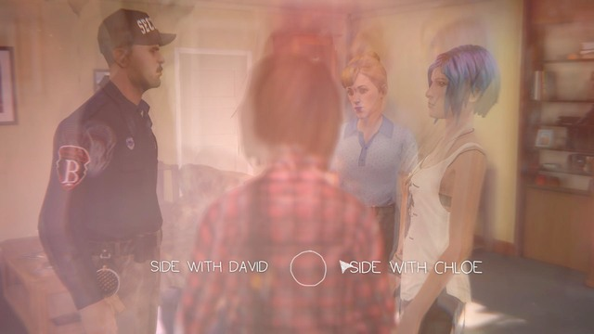

Figure : Life is strange (Dontnod Entertainment, 2015) example of choices

As you can see in Figure 4 the choice displayed for the player is very basic. Two different options that tell you pretty much what each one will do, however the player in this scenario gets to think based on the knowledge they’ve learnt throughout the game. They know and like the character Chloe and thus siding with her would be natural but at the same time siding with David could also make sense based on information the player might have found in the game. What Life is Strange does well is that it incorporates what the player has learnt from playing the game and exploring into the choices, and via this the player may have a better understanding of the possible consequences of choosing a certain choice.

So let’s take a look at what makes a meaningful choice, for this we’ll be looking at an article from a site called Gamasutra called Meaningful Choice in games: Practical Guide & Case Studies (Morrison, 2013). In this article Morrison talks about four different components in which he feels help towards creating a meaningful choice, these four components are Awareness, Gameplay consequences, Reminders, and Permanence. We’ll go over all four components and talk about his reasons behind them and how they fit in with this project as a whole and how these all help to create meaningful choices. So let’s start off with awareness. “*If the player is not aware they are making a choice between two or more options, then it isn’t meaningful.”* (Morrison, 2013)This is a very good point and definitely rings true in gaming as the player needs to feel that each choice is different so that it actually feels to them like they’re making an important choice between different actions rather than giving them say three different options on how to go about a certain task in which all options end the same with only slightly different results. This is not a meaningful choice because the choice didn’t really matter and had very little impact on the overall result, the player could have blindly selected any of the options and not really have noticed anything, and the multiple choice system might as well not be there in these scenarios. “*Imagine that a player is in a game where a character named Cindy is crying for help. The player runs over and helps Cindy. At that moment the game says you choose to save Cindy over Bernard. But the player never saw Bernard. They didn’t even know Bernard was in trouble, or that he even existed. At this point the player would probably feel frustrated. This ruins the choice and makes it meaningless.”* (Morrison, 2013) This is a very good example of a poor choice in a game, as Morrison points out the player to their knowledge do not know that there is any other character other than Cindy to save. This leaves the player angry and frustrated at the game and the choice system because it unfairly made it seem like there was a choice after doing something that didn’t feel like a choice. The player misses out on a possibility of having the choice to think over the question, instead it throws the player into a scenario where they think there’s only one choice when really there is more. It takes away the engagement of thought from the player and does not reward the player with choice and consequence. You still have to be careful in creating choices that feel significant and in the right places. Having minor choices become major choices later on can be a thing but requires reminding the player, so they remember some of the smaller choices from earlier, but we’ll talk about that in a bit. In the next section Morrison goes over gameplay consequences, something we’ve already gone over. From his article we can gather that his thoughts align with what was said earlier “*The best meaningful choices have both aesthetic AND gameplay consequences. Changing the experience of the game, the behaviour of the player, is typically more meaningful than just playing the same game with different set dressing.*” (Morrison, 2013) As you can see from this quote he believes that good meaningful choices can change not only the gameplay but also the aesthetics of the scenario which definitely can be applied to the system we’re building as if the player has the decision to change from just a mage to either an Arch mage or a Mage warrior, not only would the consequence result in different gameplay, it’d also result in a different aesthetical character.

Moving on we’ll now discuss reminders. Reminding the player of the choices they’ve made, either good or bad is a very effective way of making the prior choice feel much more meaningful, it’s the tossup between two emotions, pride and regret. That feeling of guilt when a choice of yours has a sad or negative effect and the player is now reminded of the actions they made prior, or the feeling of pride knowing that a choice you made either saved someone or helped you towards a great goal and being reminded of it by the game really gives the player a feeling of satisfaction and also feeds back into consequence. The fact the player is being reminded that their actions meant something really makes it stick with the player. Even though some actions might have immediate consequences, sometimes the best type of choice is something that blooms into something much bigger down the line with the game reminding you every now and then of this one choice you made that has lead into something so much bigger. “*If you don’t remember your previous choices, then you’ll never feel pride or regret. Or if your previous choices don’t affect your present world, then you will similarly not feel anything.”* (Morrison, 2013) This is a very good point by Morrison as this can make smaller choices early on become meaningful via reminding the player and this then allows them to think what impacts that decision had, and also might get them interested in what could have happened if they’d gone for a different option.

Finally we move onto the permanence of choices. This factor means that a choice will have impact, a choice made is permanent. This gives choices a lot more weight to them, making the player really weigh over what choice they want to make as a singular choice could change so much and allows for the player to really think and decide what they want from it. It gives the feeling of a real life scenario where all the choices we make in real life are non-changeable, there are no second chances in most real life scenarios and this factor really adds some good pressure to the player making them feel the choices they make are meaningful and need to be thought over. In this system it’d be used to make the player choose between major class upgrades, for example a thief class is given the choice to either follow his team of bandits and become a leader and a gang leader learning more about being a thief and gaining more frontal aggressive abilities, or choosing to become one of the ninjas, learning how to use stealth and assassination techniques. The player can only choose one and once the decision has been made it cannot be taken back meaning the player really needs to think what do they want to invest in more and which fits them better as a player and fits their personal character better. “*The reason that choices in real life are so fraught with emotion, with sadness, with purpose, is because they are permanent. We can’t live our lives over again. In real life, you can’t have a fight with your significant other and then rewind and do it again. You only get one shot, which is why you need to choose your words and actions very carefully*.” (Morrison, 2013) As Morrison points out this is what makes multiple choice decisions a very thoughtful process as with these kinds of systems you’ll get one shot, and you’ll live with the consequences of your decision. A good way to use this would be to have the choice between two different factions, one being say a mage focused faction and another being a warrior based faction. The option you choose will heavily impact the players class and quest lines, and choosing one will directly affect the relations of the other faction, and they’ll verbally show their disgust at the players choice, both reminding them of their choice and showing the permanence of it.

Putting all four of these factors together really does help to make choices much more meaningful as each part really compliments each other, making sure the player is aware they have two different meaningful choices but not only doing that but by making sure that both choices award the player with different story, gameplay or aesthetical gameplay elements for choosing that choice, and then reminding the player of their choice down the line and reminding them of the permanence of their choice.

## Storytelling

Now onto what could be considered the main part of this system, the storytelling itself. This is obviously a very important factor to this system as although all the other parts we’ve discussed earlier are essentially needed in a system like this, with no strong story to back it up the choices become almost boring and don’t really give the player any incentive. Story can put the meaning into the choices, and really get the player invested into the choices they are being given. Story is what drives these systems and it is why these systems are primarily used in heavy narrative games, to allow the player to go through a story with multiple branching areas. “*Story and gameplay are like oil and vinegar. Theoretically they don’t mix, but if you put them in a bottle and shake them up real good, they’re pretty good on a salad.*” (Schell, 2008) This quote sums up stories in gaming fairly well as just the two concepts together don’t mix always very well, for example there are very certain styles of games that just do not compliment story telling as well as others. The mix of the two elements really relies on the designer and their approach to crafting the experience and mixing the two different elements together to create something engaging for the player on both a gameplay level and a storytelling level. You want to be able to build a story through gameplay but not have the gameplay be limited by the story. It’s a very delicate balance that is not always easy to pull off.

The interesting part with storytelling in games that the majority of games use a system known as the String of pearls, it can be visually represented as in Figure 5.

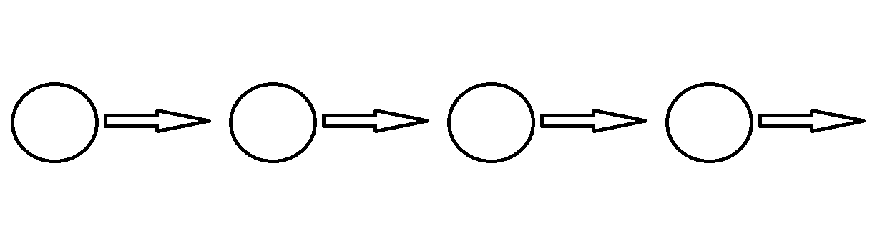

Figure : String of pearls example.

“*The idea is that a completely non-interactive story (the string) is presented in the form of text, a slideshow, or animated sequence and then the player is given a period of free movement and control (the pearl) with a fixed goal in mind. When the goal is achieved, the player travels down the string via another non-interactive sequence, to the next pearl.”* (Schell, 2008) This kind of sequence shows how stories are used in a very linear fashion. This is to give a player some form of text or animated event, giving them the information that is required for their goal, and then they are given the ability to act on this in what way they like until they hit the next string of events and then the cycle continues. This system would not work for something like our system as it’s just a straight line with no branching options what so ever, however it does work well for what it tries to achieve, a linear story line with objective based points. For our system to work we could use something like the String of pearls, but rather than only having a singular string come off a pearl, we’d have multiple strings lead to different pearls, branching off into different sections and sometimes re-joining onto old strings, it’d look something like Figure 6.

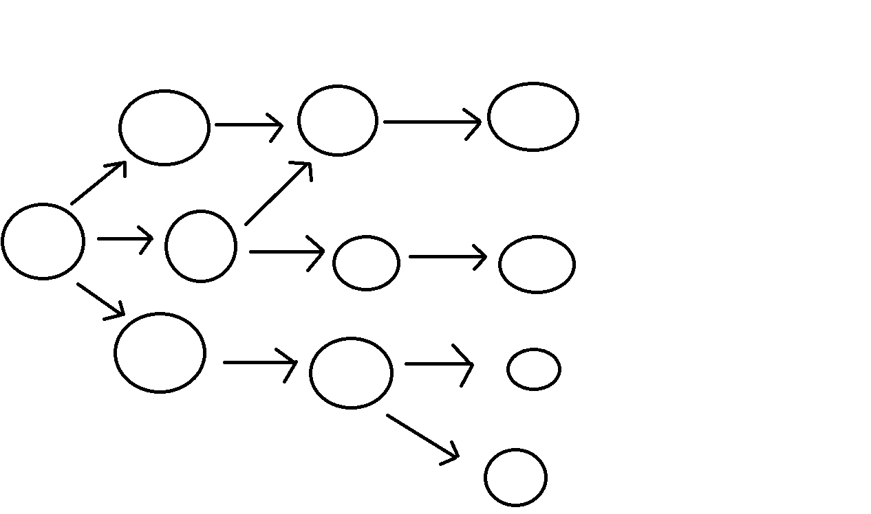

Figure : Branching string of pearls example.

As you can see in Figure 6 the branching choices are represented by the arrows coming off, the idea would be that each string would be a different choice which would then lead to a new pearl giving the player a large amount of choice and options throughout the game.

Now whilst this all may seem all positive this is not always the case as games with systems like this do run into some large problems with storytelling that must be accepted. “*One thing that interactive storytellers like to fantasize about is how wonderful it is that a story can have multiple endings. After all, this means the player will be able to play again and again with a different experience every time! And like many fantasies, the reality tends to disappoint*.” (Schell, 2008) This quote from Schell rings very true with not only multiple endings but overall multiple choices in gaming in general as not all gamers enjoy having so much choice and having the possibility of having to go through the entire game again just to see a slightly different variant of ending or class fantasy. This is true as well for the system at use here. The player might not want to go through all of the different options that are available to them just to see what’d happen differently if they’d chosen X instead of Y, or if they have it in them to start from the beginning again to try a completely different path. This is one of the major problems with multiple choice systems in that it can lead to players not wanting to replay again or sometimes even continue on if they feel too bogged down.

It’s not all doom and gloom however, some of these problems can be lessened with some good storytelling techniques that can be mixed in together with other elements such as gameplay and progression. So let’s go over some techniques to overcome some of these negative factors.

Making sure the player has goals, obstacles and conflicts, “*As the character tries to overcome the obstacles, interesting conflicts tend to arise, particularly when another character has a conflicting goal. This simple pattern leads to very interesting stories because it means the character has to engage in problem-solving (which we find very interesting), because conflicts lead to unpredictable results, in other words, surprises (which we find very interesting), and because the bigger the obstacle, the bigger the potential for dramatic change (which we find very interesting).”* (Schell, 2008) making sure the player has obstacles and conflicts to overcome motivates them to continue on, it engages them with problems and events that they’ll want to continue through to get to the next obstacle and so on. This can be applied to the system by making sure that especially major choices such as class advancements require the player to go through some sort of tough obstacle with narrative based conflicts that’ll interest the player into wanting to continue through to the end and possibly stop and think of the other possibilities they could’ve ended that conflict. It’ll encourage the player to go back at some point and explore more.

Use Simplicity and transcendence to create the story. By this what is meant is to try and make the setting of the game world simple, clear and easy for the player to digest, so that they don’t feel to overwhelmed by the world they’re in. Make it so that certain elements don’t get too out of hand, for example in a medieval based world it’ll be simpler than our current world because they won’t have the technology of what is current available, it’s much more primitive. Then also add some value to the player, making them feel stronger in this game than they do in real life, again using the medieval basis, adding magic is a common way to add transcendence to the player, giving them strength they don’t have access to in the real world. These two parts can mix together to create a powerful combination, but it can also be easily messed up as well and must be looked at with care.

Consider using the Heroes Journey. “*In 1992, Christopher Vogler, a Hollywood writer and producer, published a book called The Writer’s Journey, which was a practical guide to writing stories using the archetypes that Campbell describes.”* (Schell, 2008) As Schell say’s Vogler wrote a very good book that is used as somewhat of a guide for a lot of stories that use the theme of heroism. He goes over and gives a synopsis of the hero’s journey.

1. The Ordinary World — Establishing scenes that show our hero is a regular person leading an ordinary life.

2. The Call to Adventure — The hero is presented with a challenge that disrupts their ordinary life.

3. Refusal of the Call — The hero makes excuses about why he can’t go on the adventure.

● What kind of transcendent power do I give to the player? How can I give even more without removing challenge from the game?

● Is my combination of simplicity and transcendence contrived, or does it provide my players with a special kind of wish fulfilment?

4. Meeting with the Mentor — Some wise figure gives advice, training, or aid.

5. Crossing the Threshold — The hero leaves the ordinary world (often under pressure) and enters the adventure world.

6. Tests, Allies, Enemies — The hero faces minor challenges, makes allies, confronts enemies, and learns the workings of the adventure world.

7. Approaching the Cave — The hero encounters setbacks and needs to try something new.

8. The Ordeal — The hero faces a peak life or death crisis.

9. The Reward — The hero survives, overcomes their fear, and gets the reward.

10. The Road Back — The hero returns to the ordinary world, but the problems still aren’t all solved.

11. Resurrection — The hero faces a still greater crisis, and has to use everything he has learned.

12. Returning with the Elixir — The journey is now well and truly complete, and the hero’s success has improved the lives of everyone in the ordinary world.

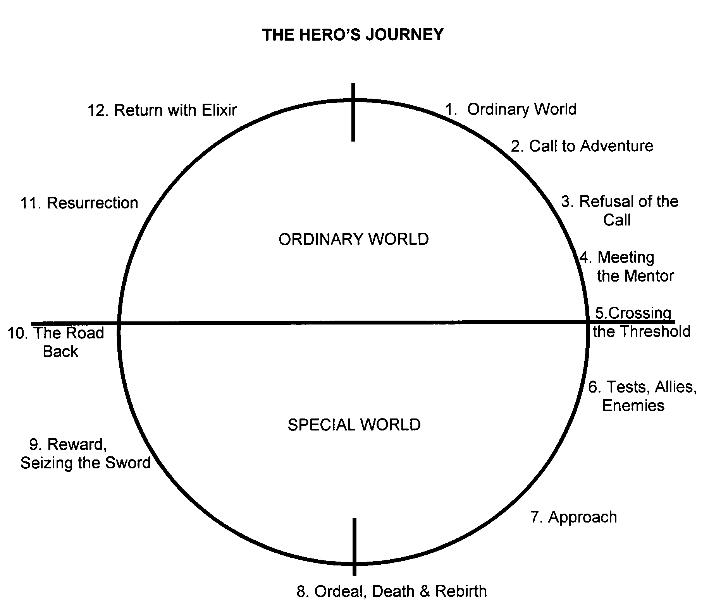

Figure : Example of the Hero's Journey (Image found at http://www.thewritersjourney.com/hero's_journey.htm)

These are the steps that Vogler thinks are needed when considering writing using the hero’s journey. This can be applied to the system via having each step of the hero’s journey apply to certain quest lines of certain lines. So going back using the string and the pearl theory on each string would be a step of the synopsis used in the hero’s journey, giving the player a reason to go on through the quests and story, ultimately leading up to the completion of the story.

## Conclusion

Now we’ve gone over the major points of this system it’s time to wrap it up, each of the factors complement each other in certain ways to create a much more involved system for the player and help create an interesting choice system for them to choose between. The multiple choice system is the core of it all, being the basis of the system and the meaningful choices give the multiple choices a meaning, and then including decent storytelling techniques makes the choices not only more valuable but help to engage the player in the choices they are making and helps make them feel involved in their class.

# Implementation

Now that we’ve covered the theory and the idea of the system as a whole, it’s time to talk about how the system was made and the steps that were taken to create the system used in this project. The system used in the project is a much more simplified version than what has been discussed above as a system that grand could take years to fully flesh out and design, but moving forward let’s take a look at how this project was made.

The project demo was made in unity using C# as the coding language. It was decided to be in 2D because it helped reduce time on creating models as getting sprites was a fairly easy task and getting them into the game was very simple.

## Step 1

So the first step taken when implementing the system was trying to decide how many classes there would be and how many events would occur. We didn’t want to go too far down the rabbit hole and get lost with tons of different branching paths so it was decided to keep it fairly simple. In the end a total of five possible outcomes were put in with a total of eleven events. Once this had been done and the events had been fleshed out we got started with working on the code. Rather than going straight into the system and trying to create everything off at once we decided to start off very small and basic and just getting the dialogue system working first.

How we created the dialogue system was via having the dialogue be stored in a string array.



Figure : Code example 1

As you can see in Figure 8 we create a public string array that allows us to edit and create multiple text lines and add as many as we want. For this we made two different strings, one for questions and one for answers.

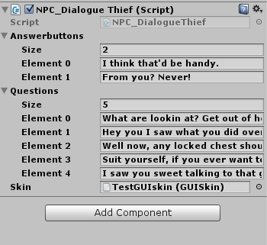

Figure : Unity script inspector for the dialogue.

As you can see in Figure 9 the two different strings are used for the questions that the NPC will ask the player, and the answers will be the possible choices the player can respond with. With that done we then move onto displaying the string. To do this we used GUIlayout label and GUIlayout button, these would take the specific selected string and display it on screen.

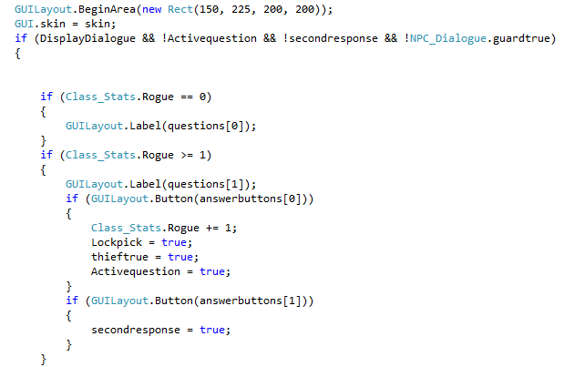

Figure : Code example 2

## Step 2

Once we’d gotten the text displaying the next step was to make the class system that’d store information regarding the choices the player made and the points towards their class. The way we did this was by setting up each class as a public static float that initially was set to 0. Each time the player would select a certain option it’d store a point into the class that the choice was associated with. So for example in the early stages we had two NPC’s, one would ask the player what their class was. If the player selected the option Mage, it’d add a point to the mage float, and when the player went over to the second NPC it’d calculate the amount of points in each class and inform the player of their current class based on the amount of points in each float. One issue that cropped up was after making the choice the NPC would still ask the same question again, so to stop this we set up a system of Booleans to trigger when a certain choice had been made. Once certain trigger points were set to true the NPC would then trigger a new dialogue option after the player had responded. This then allowed us to expand conversations with NPCs and allowed more dialogue to pop up under certain circumstances.

## Step 3

Once this system had been built up using just two NPCs and was tested to be correctly recording the correct data, the next step was implementing it into a proper scenario. A small map was made using a program called Tiled which allowed us to create a tile based map and also allowed us to create collision detection on certain sprites for when we imported it. Once this was set up in unity we then put in each NPC one at a time and coded their dialogue in and set them up as such. One of the early parts that caused issues was accessing data from one piece of code to another, the prime culprit being the class stats themselves. This was solved by setting them to be public static variables and being able to reference them nice and cleanly in the code as shown in Figure 11.



Figure : Code example 3

An early alternative was found prior to this, however it was a very long winded and clunky way of fetching code from another script so we decided that this was not only the most efficient was but a cleaner way as well.

## Step 4

Once all of the base systems were in and implemented we started to work on some of the polish of the system and had some testers come in and make sure things were working as intended and getting their feedback on the system as an idea as a whole and the system used in the demo. One of the things we did to polish up was add some limitations to the events and make it so certain events once triggered would close off the possibility to other events. For example there is a Mage who will talk to once you’ve triggered getting some mage points, however if you speak with the thief before him, he’ll notice this and refuse to teach you regardless. These sort of events added more consequence to the choices as initially it felt like you could just do everything and no choice had proper meaning and as discussed earlier, this is something we want to avoid. To do this we set up some public static Booleans that’d trigger to true once the player had completed a certain event. Once triggered the other script would detect that this was true and disable the previous dialogue options and set them to show a new set.

## Step 5

Onto the finishing touches now, the last steps were just again cleaning up the demo itself by adding a bit more life to it. This was done by adding animation to the players’ model, allowing them to feel like they’re walking around, and adding in background music. The animation was done via the sprite animation tools found in unity. We had a sprite sheet with all the different animations that’d play in a loop once the player goes a certain speed in a certain direction.

# Test results

As was stated in the implementation section, we brought in some people to help test the demo and also to ask them on their opinion on the system not only as used in the demo, but as a possible system to be used in games in general. When getting people on board for testing we wanted to try and get a slightly wider demographic than just people who play games. We ended up with five testers who play games on a regular basis and have a good knowledge of games in general, we then had another five testers who only played games every now and again for more casual entertainment, and finally we had five players who played mainly online games. The reason we wanted these different categories of testers was to try and get information back from different groups of players. To see what the staple gamer thought of this system as a whole as someone who plays games often and to completion, causal gamers who don’t often play games and normally either only to the bare minimum of completion or don’t finish games off at all, and the online gamer who plays either competitive or co-operative games online with other people, and to see how this system would appeal to them in their own each different world of gaming.

## Initial response

The initial response to the project idea was very positive, especially with the testers who played games at a more regular basis. They certainly liked the idea of the amount of possible content this kind of system could have and the different kind of options it could open to class fantasy. Whilst it was still mostly positive with the other two camps, a few questions were brought up. The casual gamers told us that whilst they really liked the idea of reinserting class fantasy back into games using this system, they’d feel quite intimidated if the system felt over bearing, and there would be the possibility that’d they’d lose were there were in the game if they took a break from it for too long. The multiplayer camp liked the idea of bringing class fantasy back a lot as they felt that was a major problem in most of the online games they played, but they were cautious of the multiple choice side and the idea of not choosing your class from the start. Their reasoning behind this was due to balance in the game and ease of access. They made it clear no choice should be better than the other, and certain exclusive items gotten from certain choices would have to not be over powered as it could cause balance issues later down the line if a certain item that could only be gotten down one path becomes very strong at a certain point. As for the ease of access, they like setting their characters class initially as it means they don’t have to worry when it comes to levelling second classes as much.

It was very interesting hearing these thoughts, while some being something we’d already thought could be an issue (primarily the thoughts of the casual players) the thoughts of the online players was definitely interesting and something that had not been considered.

## Initial testing

Once we’d gotten their initial thoughts on the system as a whole we let them try an early version of the demo, with most of the system in place. As expected a few stereotypes started to show from these. Both the more regular gamers and the online gamers would try and explore as much as they could and find out certain results. They’d also reset and try and see other possible endings whilst the casual gamers would be a bit slower and would play through only once or twice. Another difference that was noted was that the more regular gamers would on read the text and try and get an understanding of what was going on, whilst the multiplayer group would mostly get a quick gist of what the choices were and what they thought the options would lead to and go through it swiftly.

The initial testing feedback we got from all the testers greatly helped with how we shaped the demo. For example almost every tester had one similar complaint and that was with a certain chest event that was set up. The event allowed the player to attempt to pick the lock of this chest and if they’d learnt the proper skills from another thief they’d be able to unlock it and gain more class points in the thief class, however initially if you didn’t have the skill when you attempted it the lock would break cutting the player off straight away. The complaint was that the player had no way of knowing if they had the required skill to unlock the chest, there was no feedback initially to let them know that they did not have the skills, to compensate for this we added in a message if the player did not have the pick lock skill unlocked and they could still attempt to unlock it if they desired. Only two of the more regular gamers did not think this was much of an issue as they thought it was obvious they wouldn’t have the skills required to unlock it early on and the risk was something that added something of consequence to the event. After the change everyone agreed that the change was good and was balanced enough to not punish players early on but still give them the option if they wanted to try it.

## Conclusion of testing

Once the final version had been tested by all we discussed the system as a whole with everyone and got everybody’s thought on the system in the demo and the system as a whole, how they liked it and how they’d like it to work. From the feedback gathered the final conclusion is that people agree that this would work very well in single player RPG games with the intention of having a huge story line, examples the testers gave as examples included games such as Mass effect, Dragon age and Elder Scrolls: Skyrim, as they believe it’d expand the player engagement and make classes feel important again rather than a label with certain skills, but no story attached. A surprising conclusion that most of the testers came to is that this system could also work very well as a tutorial system rather than a full in game feature due to the fact this can allow you to get to know your class, and the people who the player will be interacting with and give them an idea into the class fantasy. The demo played felt like a tutorial and gave a feeling of intro level into deciding what class to go and gives the player options on how they want to act. The online gamers said whilst they worried about the balance issues that could arise from such a system they’d love to see some sort of system to enhance their class engagement and something like this might still be a large plus if done correctly. The casual gamers still stuck by their initial thoughts, whilst enjoying the idea of the system it could become overwhelming for them, and while they enjoy the idea of finding out more about their class, they were worried they’d never be able to explore all of their class, let alone all of the classes. The regular gamers were completely in favour of this system claiming that it could help to bring back class fantasy and could expand the story of games. One suggestion the testers gave was the possibility of a second level that’d reflect the choices they’d made. This would then show and remind the player of their choices and show more consequence. This was a fantastic idea that could’ve been implemented if more time was available.

## Overall thoughts

Onto our thoughts of the testing process a lot of interesting discoveries were found throughout this process. It was good to get a range of different types of players because it allows for more feedback from a different range of player base and knowing what player base would enjoy this system is good to know. For example going into this we had a feeling that casual gamers might not be into the idea to much as this system can become very time consuming for the player and can lead to some confusing scenarios, however we didn’t think that online players would also be slightly against the methods of the system in the way they were, and it was very interesting to hear their side as to how to balance it. Overall hearing back from everybody and hearing that the system has potential is very good to hear. From these testers we’ve learnt quite a bit and changed up how certain parts of the demo itself worked, such as thinking about making the items gained from choices to be balanced as possible making no choice so much more powerful than another, to try and make it so it doesn’t feel too overwhelming for players who aren’t as comfortable with these branching systems, and making sure that the choices don’t feel unfair or cheap when selecting them and making it clear that a negative choice is one.

# Conclusion

Overall a lot has been learnt throughout the course of this project. We’ve gone over the importance of multiple choices in gaming and how to make the choices meaningful, and adding a story to it that can make it not only meaningful but also engaging. When it comes to the demo there is definitely more that could’ve been done if planning had been better. Either earlier research into possibly more complex ways of managing data could’ve made this project more technical and added a bit more depth to the code and possibly could have made a smoother and more expansive system to store data. As said in the conclusion of testing a second level could have been implemented to try and show off some more conclusions of the things the player did, however we did not think this far ahead when initially planning this out due to fears of making the project to over complicated. We didn’t initially want more than ten events to try and keep any branching as simple as possible, but it could’ve have been possible to add in something even if it was just a small level based on the choices the player had made. This could be something to add to it after this project and something that be continue upon. The most important thing to take from this project is that meaningful choices in the end really do decide how these systems can work regardless of how and where the choice is placed. For example this theory does not change just because in this project the system is centred on classes. All the choices must feel meaningful and feel like they’re reasonable and make sense for that class. It wouldn’t make sense if a simple choice that felt almost meaningless ends up being a major decision which decides your class, so you’ve got be really careful when it comes to not just making the choice feel meaningful, but making sure the player knows what they’re getting themselves into.

If things could be done differently and the project reset with the knowledge we have now work and research towards this project would probably start a bit earlier and also work on different storing systems would be done much earlier and research into coding and managing systems would be done as well. The theory part we feel is fairly complete, more research into these systems could always be done, and possibly a large scale questionnaire could have been done and sent out online to try and gain more knowledge on what the player base thinks of such a system. However the aim of the project was not to see what people think but more if such a system could be created and implemented into a world. Another thing that could’ve had a bit more polish is the possibility of more testers from a wider area of games genres rather than just different types of players as one thing that we focused on was using this system for RPGs, it’d could’ve been nice to see what other players from other genres would think about this kind of system and how it could be implemented in other genres other than RPGs.

Overall this has been an exciting journey to have been a part of. There have been highs and lows to it all and overall we’re very proud of what has been learnt from this project and will take the things that have been learnt and use them to push this system further and try and implement it and make it grow as much as possible. With all that being said thank you for reading this project and hopefully this system has taught some lessons in regards to building a multiple conversation system and building it with meaningful choices and correct story building techniques.

# Bibliography

Bethesda Game Studios.(2010). *Elder Scrolls: Skyrim*.[DISC]. PC/Xbox 360/PS3. Rockville: Bethesda Softworks

Bioware. (2007). *Mass Effect.*[DISC]. Xbox 360. Edmonton: EA Games

Bioware. (2009). *Dragon Age.*[DISC]. Xbox 360. Edmonton: EA Games

Dontnod Entertainment.(2015). *Life Is Strange*.[DIGITAL] PC. Paris: Square Enix

Fabulich, D. (2010, March 28). *5 Rules for Writing Interesting Choices in Multiple-Choice Games*. Retrieved August 29, 2016, from choiceofgames.com: https://www.choiceofgames.com/2010/03/5-rules-for-writing-interesting-choices-in-multiple-choice-games/

Montgomery, R. A. (1979). *Journey Under the Sea.* Waitsfield: Chooseco.

Morrison, B. (2013, September 19). *Meaningful Choice in Games: Practical Guide & Case Studies*. Retrieved September 1, 2016, from Gamasutra: http://www.gamasutra.com/blogs/BriceMorrison/20131119/204733/Meaningful_Choice_in_Games_Practical_Guide__Case_Studies.php

Schell, J. (2008). *The Art of Games design a Book of Lenses.* Burlington : Morgan Kaufmann.

Telltale Games.(2012). *The Walking Dead*.[DIGITAL].PC. San Rafael: TellTale Games

Vogler, C. (2007). *The Writer's Journey: Mythic Structure for Writers.* California: Michael Wiese Productions.

Vogler, C. (n.d.). *The Hero's Journey Outline*. Retrieved September 2, 2016, from The writers journey: http://www.thewritersjourney.com/hero's_journey.htm#Hero